**Metropolitan Council Mobility Hubs Siting and Prioritization Method**

**All of these (outcome a, b, d) are combined with a new weight (adjustable to policy goals)**

Final piece of this was overlaying parks, TOD zones, equity zones, and transit stop buffers to capture functionality, design elements, and implementation guidance based on context

Procedure used GIS and R, can be easily updated with updated data

Outputs:

Other approaches for bikeshare system design:  
TO READ García-Palomares et al., 2012

Minimizing impedance aims to locate stations across a study area so distance between stations is minimized, and maximizing coverage aims to locate stations where the most potential demand (population) is served. While such a modeling approach identifies good locations for stations within the study area based on specific model objectives and parameters, it has notable lim- itations. Coverage optimization ensures that the greatest amount of benefit is provided by the system in terms of serving demand, but does not account for social equity within that population in terms of income or other factors.

(Frade and Ribeiro, 2015)

Projected user demand and budgetary constraints within travel zones, consider the fiscal realities of investing in and implementing bicycle share, the results do not identify the specific locations for the stations and consider only initial investment budgets.

Church and Murray, 2009 – analyzing methods

Restricting the analysis of station location to a particular number of stations (or budget) may offer insight for the initial phase of bicycle share system installation, but system expansion would require subsequent analyses, lacking integration and would likely introduce system inefficiency

An effective approach for system design would consider the optimal number and location of stations at a **given service standard** and would **identify how best to install these stations given a particular configuration**.

(Wei et al, 2014)

the way in which con- tinuous space coverage goals can be achieved through the use of dis- crete optimization approaches, and serves as a basis for identifying potential sites (see also Murray and Tong, 2007)

(Fishman et al, 2014)

OTHER USEFUL THINGS

Most users are willing to travel up to a half-mile on foot to access a bicycle share station (Bachand-Marleau et al., 2012).

An optimization approach for equitable bicycle share station siting Lindsey Conrowa,⁎, Alan T. Murrayb, Heather A. Fischera

If the desire is to ensure that no user would have to travel more than a half-mile to reach a station, and no more than one mile between stations, how many stations would we need and where should they be located?

The objective function of the model minimizes the number of facilities sited while the constraints specify that the en- tirety of the network (arcs) must be fully covered by the set of selected facilities, with facilities sited along the network. The practical solution approach for this analysis was to generate and iteratively modify a point representation of the bicycle network until full coverage of the network was achieved. At each iteration, coverage was determined, the point representation was modified, and an optimal solution for that point set was found. Fig. 2 shows the optimal solution that was used for potential bicycle station sites.

The modeling goal is to site bicycle share facilities such that the greatest demand, both service and population, possible is served.

For all points capable of serving a given user demand: if site selected and network segment covered, don’t add anything. If site selected but doesn’t cover segment add one (penalty for uselessness), if site not selected but network segment is covered (through a different point selection), subtract one (reward). For all segments a constraint: should sum up to less than or equal to 0

For all points capable of serving a given bike network segment: if site selected and user demand covered, don’t add anything. If site selected but doesn’t cover user demand add one (penalty), if site not selected but user demand is covered, subtract one (reward). For all user demands (population blocks), a constraint: should sum up to less than or equal to 0

My version currently just looks at objective function (2), has a similar constraint (5)

If w is higher than 0.5, coverage of network segments is prioritized over coverage of user demand

**“Depending on specific planning goals, other measures of demand, such as proxi- mity to public transport links or low-income areas, could also be used.”**

**“Investment level p and objective priority weights w were varied to obtain a range of decision making alternatives… The solutions obtained enable a number of potentially interesting tradeoffs to be considered, such as: Objective (1) vs. Objective (2) for a given value of p; Objective (1) vs. p; and Objective (2) vs. p”**

Notes: in smaller/medium-sized urban aeas, bike facilities might be very limited and optimizing to bike network coverage might not be the most beneficial approach.

Optimizing the location of stations in bike-sharing programs: A GIS approach Juan Carlos García-Palomares*, Javier Gutiérrez, Marta Latorre

This method just looks at accessibility of demand points (trip generators and attractors) (with stations broken out into categories of ‘Generators’, ’Mixed’, ’Attractors’, and ‘High Attractors’) and runs a location-allocation model that tries to either 1) minimize impedance (reducing travel times between demand points) or 2) maximize coverage (cover as many demand points as possible) with the same constraint of number of stations

“In any bike-sharing program, one of the keys to success is the location and distribution of bike stations (Lin & Yang, 2011). However, most authors and preliminary studies tend to give only general recommendations regarding the station implementation.”

Predicting non-motorized travel; (Rybarczyk & Wu, 2011; Schwartz, 1999; Turner, Hotternstein, & Shunk, 1997) Landis (1996) proposed the latent demand score (LDS) model to estimate travel demand based on bicycle trip generators and attractors, such as employment, shopping centers, parks and schools.

“Knowing the distribution of the potential demand and dis- tinguishing areas that are trip generators from those that are trip attractors also makes it possible to anticipate the asymmetric travel demands of most large cities. This process is fundamental in the planning of bicycle-redistribution systems.” **I think this concept could be applied with the zone creation for my project—residential neighborhoods are generators, employment centers are attractors**

**“However, such a high density of stations requires substantial investment, and some authors have noted that overcoverage may be detrimental to the success of the system because it increases maintenance costs (Shu et al., 2010).”**

**“Other studies are already making use of GIS as a support tool for assessing bicycle facility planning. Rybarczyk and Wu (2010) use GIS to evaluate supply- and demand-based models together in different territorial units (street segments and neighborhoods). These authors calculate the distribution of the latent demand score (Landis, 1996) while obtaining a bicycle level-of-service index (Harkey, Reinfurt & Knuiman, 1998). The results of both indicators are analyzed using exploratory spatial data analysis (ESDA) and Moran-I, with the aim of carrying out a joint evaluation. Larsen, Patterson, and El-Geneidy, (in press) propose a GIS methodology aimed at obtaining optimal locations for new routes, minor linkages and upgrades in the Montreal cycling network. The authors use multi-criteria methods to integrate information on current cyclist trips, short car trips (potential cycling), segments of bicycle paths suggested by survey respondents, bicycle crash data and dangling nodes on the existing bicycle network. Although the authors do not apply the method, they note that this same method could help identify areas in which to invest in bicycle parking spaces and/or public bicycle stations.”**

“Optimal location tools for services (location-allocation models) have been implemented in a GIS environment, which may be of great use for locating bike stations with relation to the distribution of potential demand. This model consists of finding where facilities of a given type should be located and what their capacity should be to meet some predefined objective while satisfying demand from a given number of centers (Ribero & Pais, 2002).”

“With respect to the solutions, a distinction can generally be made between efficient and equity- oriented models (Murray, 2010). Of the models proposed, the p- median problem (Hakimi, 1965) is the most common. The objective is to minimize the total demand-weighted travel to service facilities. Two other general approaches are center and covering. Hakimi (1964, 1965) described the p-center problem, with the intent of locating p facilities to minimize the maximum distance that a demand point was from its closest facility. Toregas, Swain, ReVelle, and Bergman (1971) formalized a location model in which the minimum number and location of facilities is to be found that guarantees a standard of service coverage or range in the context of central place theory. Service provision equates to the coverage of demand. A minimal set of facilities is sought such that demand points are responded to or served within a maximum travel time/distance. This model was called the location set covering problem (LSCP)”

**Notes:** It seems you can either set objective function to minimize # facilities to given a specified service coverage (either demand or spatial coverage), or set objective function to maximize coverage (either demand or spatial), given a specified # facilities.

Working with three concepts:

-spatial coverage (bike facilities or just space in the service area)

-demand coverage (proximity to people/jobs, trip generators/attractors, etc) **(have not noticed many models with weighted demand points)**

-cost (# of stations) (**have not noticed many models with variable cost**)

My current formulation tries to maximize demand coverage, using constraints of spatial coverage and cost

The location set covering problem tries to minimize cost, using constraints of spatial coverage

The maximal coverage location problem tries to maximize the demand coverage within spatial coverage constraints

In the location-allocation model in this paper, two different problems are evaluated:

Minimize impedance (P-Median) minimize the sum of the weighted costs between demand points

Maximize coverage – as many demand points as possible are allocated to solution facilities within the impedance cutoff

“Recognizing practical limitations to the LSCP, Church and ReVelle (1974) formulated the maximal coverage location problem (MCLP), in which p facilities are to be sited to maximize demand served within the stipulated standard.”

**Definitely test different # of stations, different weights of inputs versus objective value, accessibility**

**Potential analysis tool—exploring different policy priorities and different budgets to determine best allocation**

**Evaluate if objective value and accessibility improvement are correlated? In what instances (which input weights) are they correlated?**

**Other outputs to evaluate: station density**

**Consider different scenarios with weights: a system that prioritizes tourism/recreation, a system that prioritizes commuting for work/school using only cycling, a system that prioritizes first/last mile transit connectivity. Could look at outputs avg distance to recreation, avg distance to workplace, avg distance to transit stop**

**Apply this with selected stations, Mj being the LEHD points(+population? Could randomly scatter points within TAZ reflecting population) within a quarter mile distance of destination station j, Tij as bike trip time, and alpha=2 like in this study.**

“This way, it is possible to prioritize stations within the bike-sharing program (eliminating those with poor accessibility) and identify those stations requiring greater attention with respect to management (those with very high accessibility).”

I don’t know if accessibility as the sole metric is very equitable, or if it works for a less dense medium/small city

Things that are unique to my approach:

* Combines propensity analysis part (hot spots) with optimization part
* GIS-based with easily accessible data (TAZ shapefile data, ACS data, LEHD data, and municipal files with transit stop data, bike facility data) **CONTINUING**
* Maximal Coverage Location Problem (with a policy-variable method for selecting candidate facility (station) locations and flexibility defining spatial coverage locations (zones))
  + maximizing demand coverage (through spatial index value), constrained # stations, constrained spatial coverage (zones)
* **COMPREHENSIVE** input considerations (proximity to households, to work/school locations, to recreational facilities, to transit, for equity) so that it can be flexibly tailored to specific community goals (ie to serve as first/last mile connectivity, to promote recreation/tourism, to allow for cycling commute, to promote transportation equity)
* AHP process for defining input weights (many survey responses makes it **COOPERATIVE**)

Propensity Analysis:

-mpls mobility hubs

-DC bikeshare station siting

-Chicago, IL high impact prioritization of bikeshare program investment

Coverage Optimization:

-Madrid, Spain GIS-based optimization location-allocation model (minimize impedance v maximize coverage)

-Phoenix, AZ Bike share equity biobjective coverage optimization (maximize both demand coverage and spatial coverage of bike network)

DO: introduction/background, literature review (Current practice station siting, optimization applications for bikeshare, ) with table

Google scholar – papers that have cited this paper

Transportation Research Part A

**MCLP Problem:**

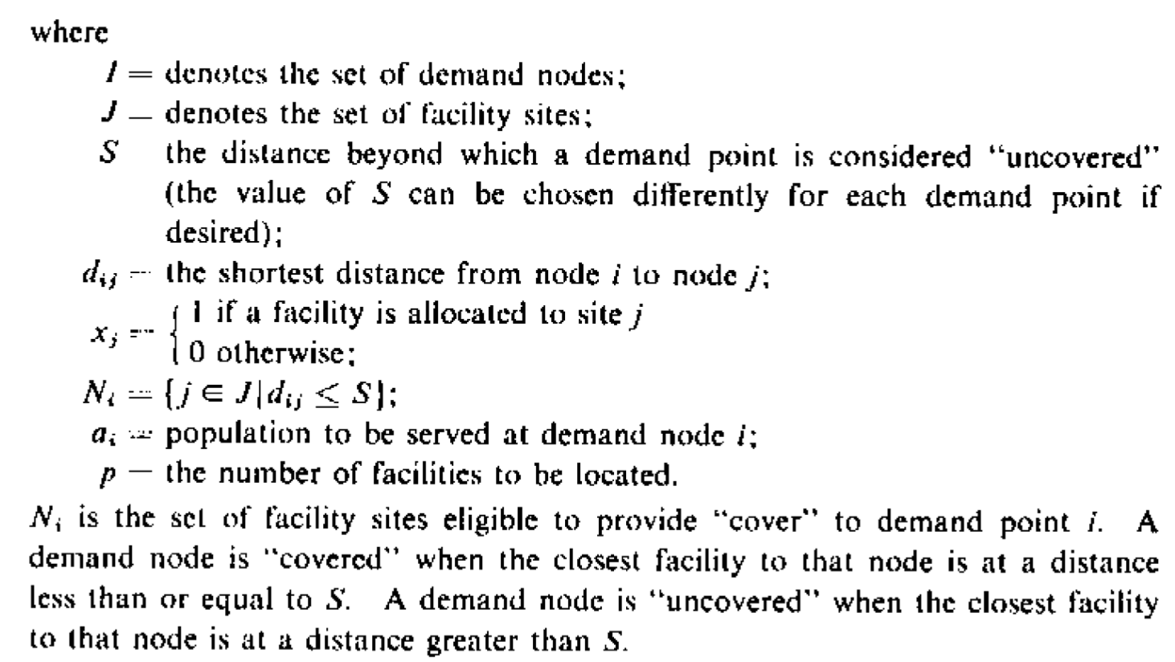

With demand points y and facility points x, maximize the value of the demand points covered y, with a constrained number of facility points and with the constraint that the facility points selected cover all desired demand points at least once. (coverage is defined as a certain distance S between facility and demand points)

Requires a predefined selection of candidate facility points and predefined selection of demand points that for sure should be covered

DC system propensity analysis weighting:

Three different categories assessed (high ridership, high revenue, public welfare)

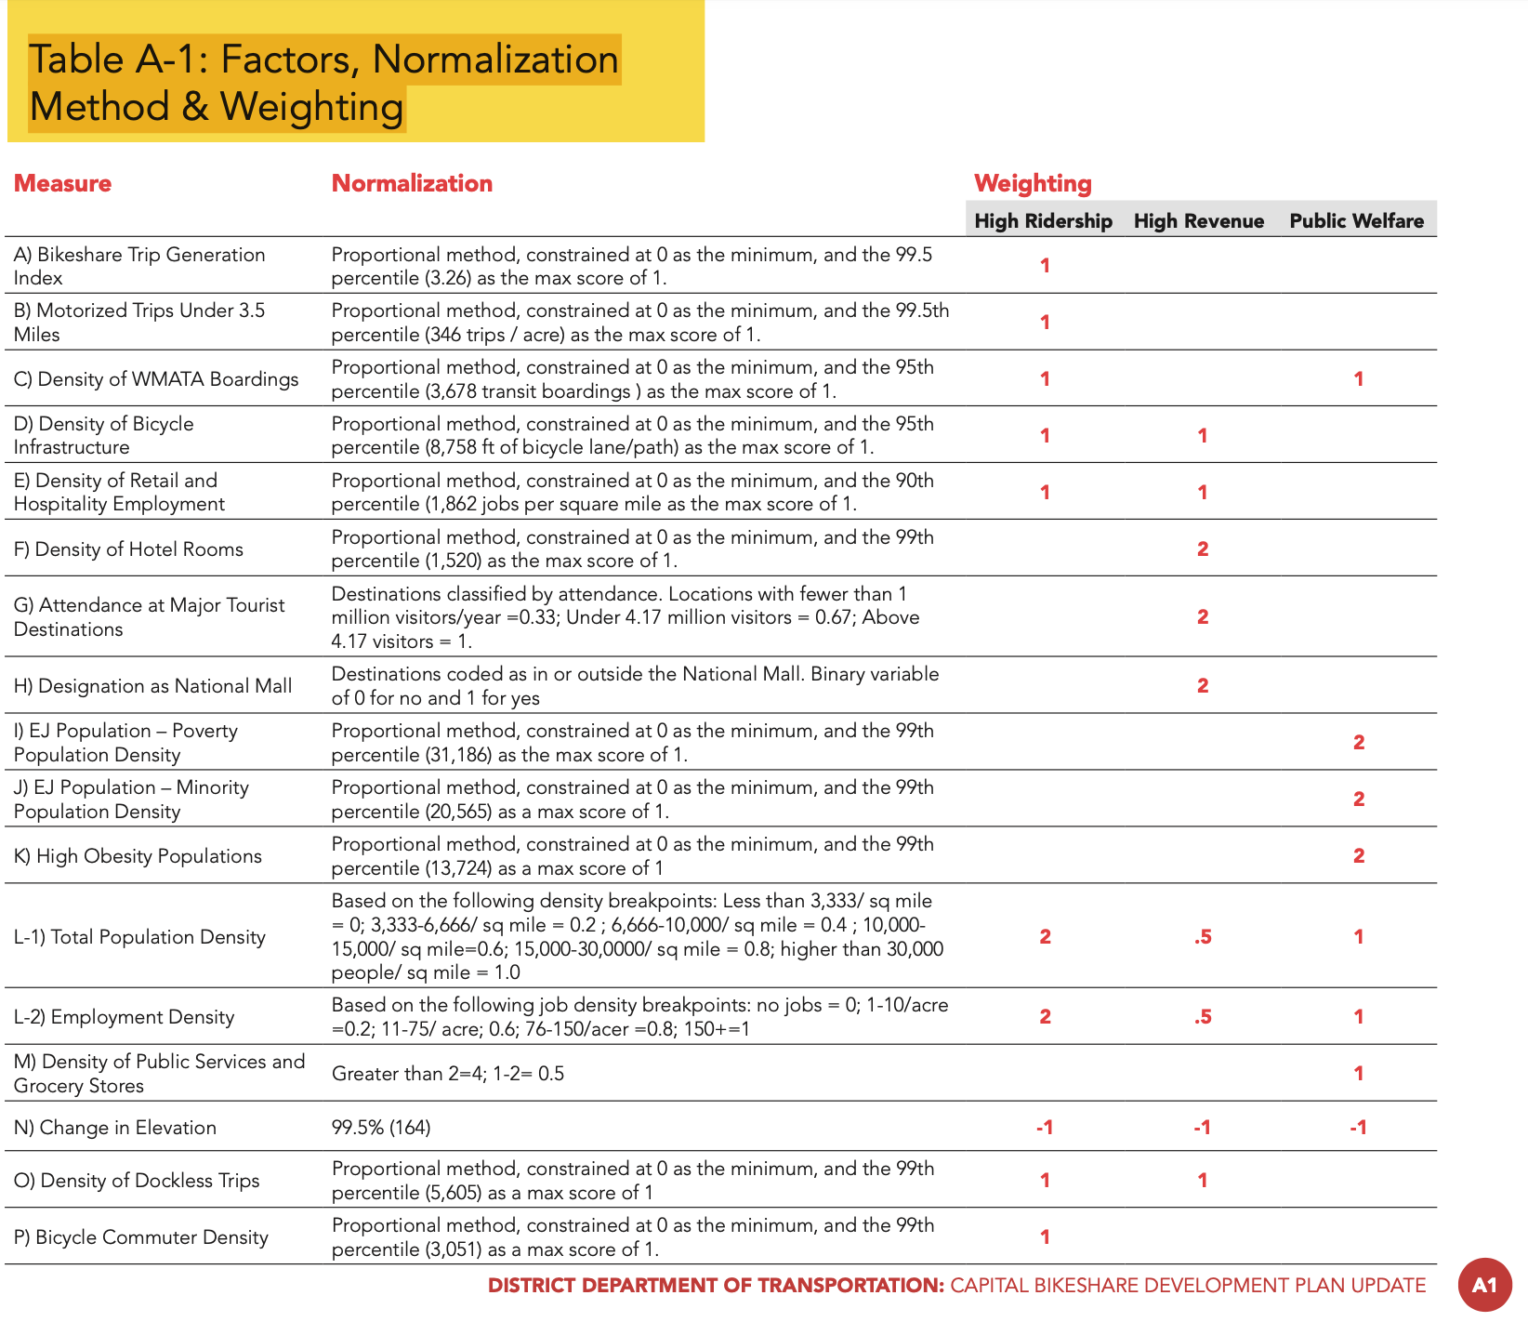

**NOTE some things are scored negatively**